##### Science of Sound Workshops led by Will Embliss

For Years 4, 5 and 6

This exciting workshop covers the "Changing Sounds" unit of the National Curriculum.

Will's insight as a musical instrument designer makes this a thoroughly engaging workshop.

Every pupil takes part in a demonstration using all sorts of unusual instruments including: - broomsticks; a conch shell; penny whistles; straws; guitar strings; a slinky; a trumpet; a trombone; plastic tubing; a marimba; plastic bottles; a metallophone; a batonka; a tuning fork; a djembe; water and a helium balloon.

**In the process pupils will learn:**

* How to differentiate between **Pitch**and **Volume.**
* How sound travels through **Solids, Liquids**and**Gases,**but not through a **Vacuum.**
* How to vary pitch on **Strings, Wind, Brass**and**Percussion.**

The workshop is designed for 30 pupils and lasts 90 minutes  Cost £95

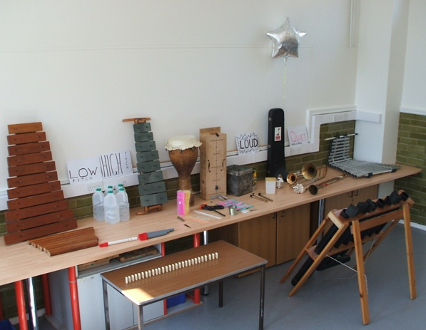

### The session lasts 90 minutes and costs £95 per class

Includes a follow up quiz reminds your pupils of every aspect of the workshop

“The way you conducted the session taught the children so much about sound. During a plenary later that day, it was obvious that all the children had learnt a lot from the workshop” Irene Tyrell, Head of St Martin of Porres

“Brilliant workshop, so interactive and different from last year.”

National Science Teacher of the Year 2012, Tracy Kilkenny, Muswell Hill Primary

**Contact Will 07946 625 957 or 0208 351 3121**

[**willembliss@gmail.com**](mailto:willembliss@gmail.com)

**78 Devonshire Hill Lane, London, N17 7NG**

**Maker of instruments for schools, playgrounds and musicians incl. Dame Evelyn Glennie** [www.willembliss.co.uk](http://www.willembliss.co.uk)